**Database Name:geolocation**

**Table_name:register**

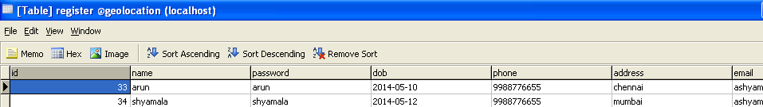

**Table name:proxy:**

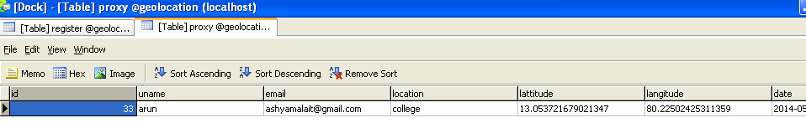

**Table Name:index_server**

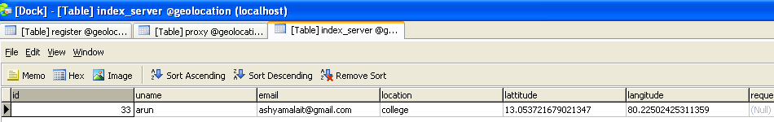

**Table Name:server**

